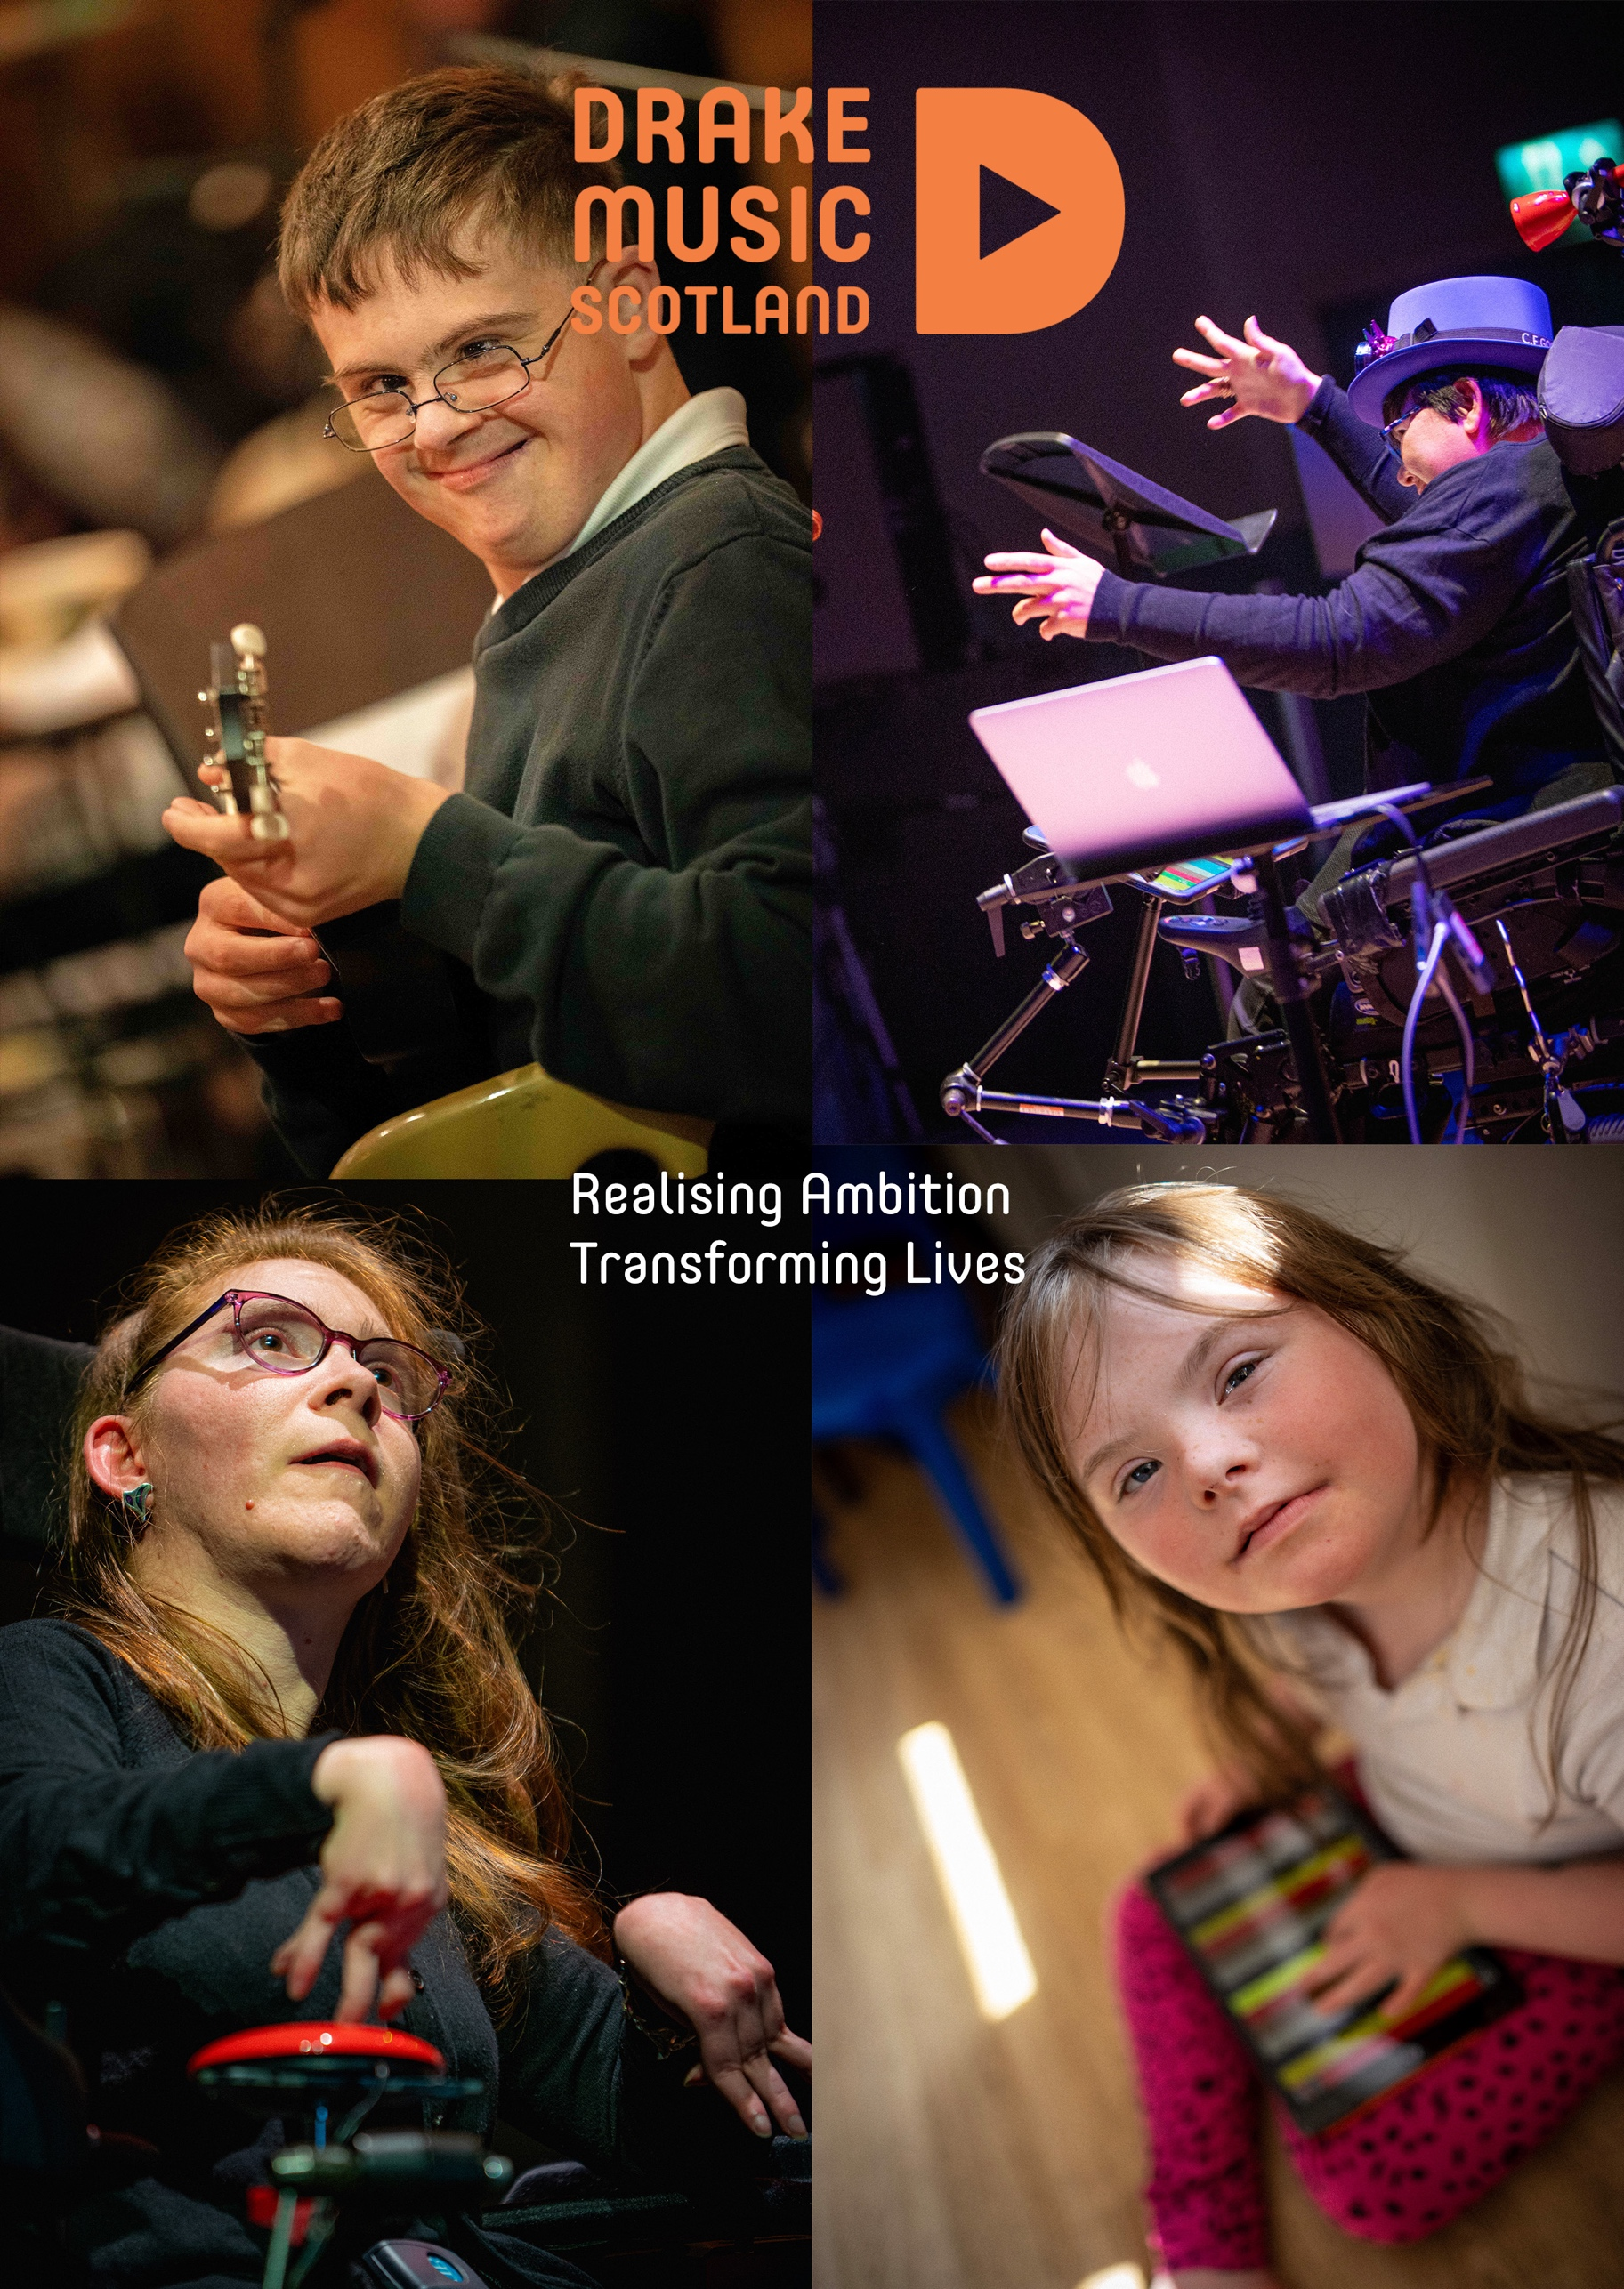
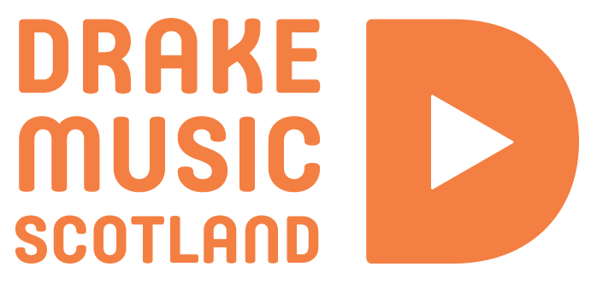
Drake Music Scotland
is currently seeking
an individual to take on the role of Project Coordinator.

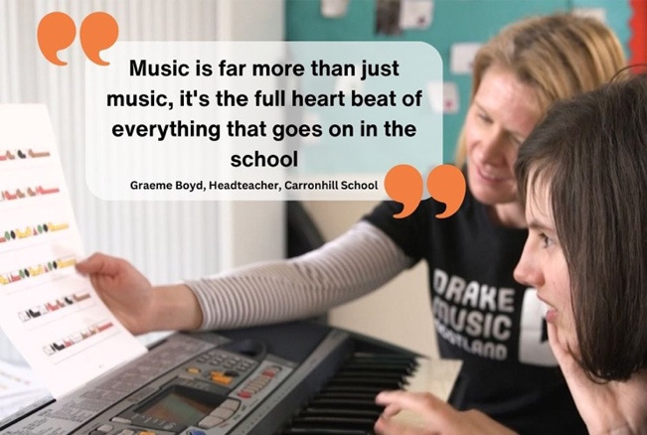
Artistic Ambition Unbound
Drake Music Scotland (DMS) was established in 1997 with the aim of creating opportunities for disabled people and additional support needs of all ages to have access to music making.

We at Drake Music Scotland believe that everyone is able to participate actively in music and should have access to appropriate resources to enable them to do so. Working throughout Scotland, we develop high quality provision through specialised expertise, training and the use of a range of music technologies and methodologies.

Our Work
Drake Music Scotland puts creative artists and musicians at the heart of our work, creating opportunities for them to have their voices heard and achieve their artistic and musical ambitions. Our work is informed by the social model of disability.

We develop every area of our working practice to improve access to music at all levels, provide appropriate support to artists, musicians and learners and diversify our workforce.

Aims and Objectives
Our Artistic Programme CREATE is artist-led, with projects to support disabled and neuro-diverse artists, music creators and performers to curate, co-create and produce high quality artistic work with a programme of public performances.

We support the ongoing creative development of the artists, Digital Orchestra and other musicians at our base in Edinburgh and in other settings, working with partners to maximise opportunities for them to participate in the mainstream arts environment in Scotland and beyond and join the music workforce.

Our programme of artistic practice and skills development and support to access career building opportunities is designed around individual artists’ needs.

We work with the Disabled Artist Network to widen opportunities and lead on initiatives to develop equalities, diversity and inclusion in the wider arts and music sector.
Our music education programme, LEARN builds on the foundation of our programme in schools and excellent track record of leadership in our sector, in a strategic drive towards making Scotland a world centre for excellence and inclusion in music education.

Our All Join In programme delivers music education projects to groups and individuals across 15 local authorities, in 60 schools with around 1,400 young people every year.

A key strategic aim for LEARN is to support the self-expression and progression of young disabled people through and beyond school to adult life with our Digital Orchestra Youth programme, strengthening musical pathways.
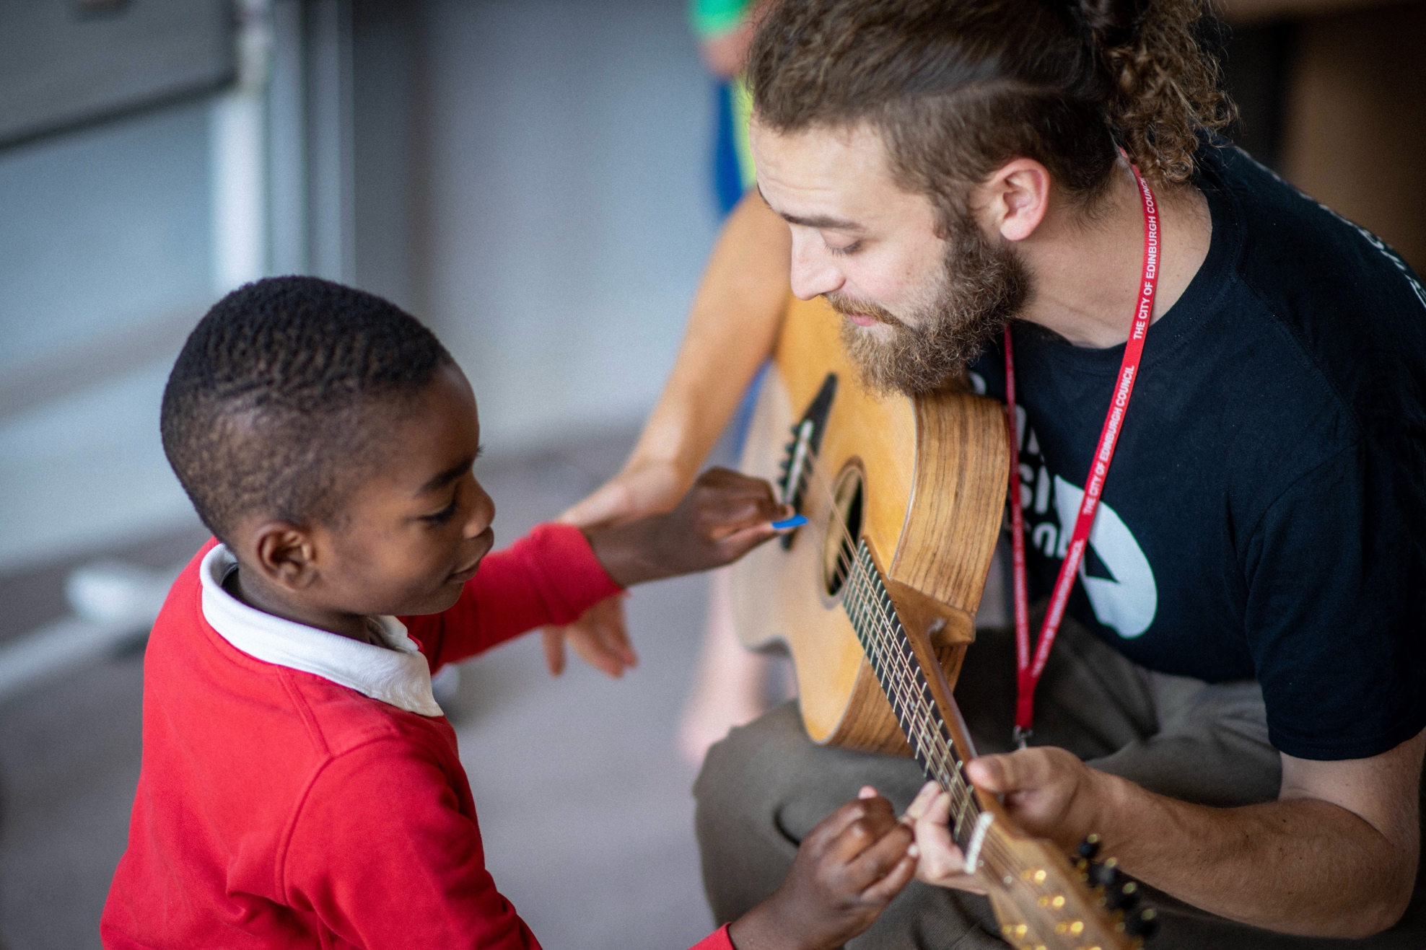

With our Skills and Leadership programme, we support educators’ musical experiences through tailored support and training.

A key part of our delivery, training and support across all of DMS’s work, is Figurenotes, an alternative form of notation which we deliver and. support internationally.

We work with partners from across the formal and informal sectors including the Music Education Partnership Group, HITS and the new National Centre for Music and develop wider awareness of best practice and expertise in inclusive music through training and CPD.

The Role
Title: Project Coordinator
Hours: Full time, 35 hours per week
Location: DMS Office, Edinburgh based with flexibility to work from home part of the time by agreement
Salary: £26,000 per annum
Holiday: 35 days per annum (inclusive of Bank Holidays)
Probation: Three months
Duration: Permanent
Pension: Company Pension Plan
Line Manager: Head of Learning
Closing date: Monday 8th June 2026 at 5pm
Interviews: Week beginning 22nd June 2026

How to Apply
This Recruitment Pack is available through our website, by email, or by phoning Drake Music Scotland - see contact details below.

Please read through the role responsibilities and person specification in this document carefully including the Detailed Job Description below. Please also look at our website: https://drakemusicscotland.org/jobs/

If you have a disability or long-term health condition, childcare responsibilities or are affected by any other factors such as a poor internet connection that may
make the recruitment process more challenging or prohibitive, please do get in touch with us at: recruitment@drakemusicscotland.org or call
0131 659 4766 to discuss any access needs or requirements.

To apply, please send a CV and covering letter of around, but no more than 2 pages of A4 detailing why you are suitable for this role, with ‘Project Coordinator Application’ in the subject line for the attention of Emma Lines, Head of Learning to: recruitment@drakemusicscotland.org by Monday 8th June 2026 at 5pm. Interviews will take place during the week beginning 22nd June 2026.

We request that you also let us know where you saw the role advertised and complete and attach our Equal Opportunities Monitoring form on our website, which will be stored separately and used for monitoring purposes only.

Our Commitment to Equality
Drake Music Scotland’s work is informed by the social model of disability which is based on the understanding that people face disabling barriers to full participation in society, asserting that the physical, attitudinal, communication and social environment must change, and these barriers be removed to enable people to participate in society on an equal basis with others.

We continue to develop EDI in every area of our work to improve access to music at all levels, provide appropriate support to artists, musicians and learners and diversify our workforce and Board.

Drake Music Scotland is an Equal Opportunities employer. We are committed to equality and inclusivity across our work and organisation.

We welcome applicants with lived experience of disability and with long-term or chronic health conditions and will make any reasonable adjustments required for any part of the recruitment process, and to support you in your role. Disabled candidates who meet the essential criteria will be invited to interview.

In addition, we welcome applicants from those protected under the 2010 Equalities Act due to age, gender reassignment, marriage and civil partnership, pregnancy and maternity, race, religion or belief, sex and sexual orientation and those with caring responsibilities. We will accept applications in any format and meet interview expenses.

We are a committed to supporting employees and improving the quality of their working life by offering flexible working opportunities and other forms of support.

Role Description
The Project Coordinator will have two main areas of
responsibility. The main area is project coordinator for the LEARN Schools programme, and the other is to provide support to the Drake Music Scotland team with some administrative and finance duties.

The post holder will have the following Key Duties as
outlined below. The exact nature of these duties and
responsibilities may vary and the post-holder will be
expected to work flexibly and carry out any work that is reasonably required as part of the post.

Key Duties
LEARN Programme
- Work closely with the Head of Learning on all projects that come under the LEARN programme

- Within the timelines and budgets of the LEARN programme, support the delivery of the programme objectives with guidance from Head of Learning. Budgets will be agreed and overseen by the Head of Learning throughout the programme

- Contact and consult school staff and participants on ideas for resources/themes, and occasional liaison with Local Authorities’ representatives and with their input

- Day-to-day liaison with schools and freelance Associate Musician team including scheduling project dates and following up on project monitoring and evaluation

- Issue agreements with details of payments to freelancers, and ensure the relevant paperwork including reports and invoices are received as per agreements

- Compile evaluation documentation for reports to the DMS senior team, Board and funders

- Documentation and marketing tasks including collecting images, video clips, and contributing to the LEARN social media presence

Other Duties
- Compile finance documentation for Drake Music Scotland, such as invoices, purchases etc. for processing with our external Bookkeeping team

- General administrative duties including manning the office, answering the phone and handling general enquiries, forwarding enquiries on to relevant members of the DMS Team

- Work as a key member of the team contributing positively to the ongoing programme, new developments and attending Team Meetings Promote the values, activities and products of Drake Music Scotland

- Be responsible for their own programme of work and liaise with project personnel in planning and scheduling

- Be prepared to work at the DMS office base,
sometimes later than normal office hours and on occasion open and close the office and studio

- Be prepared to undertake professional development
activities including to build skills relating to the job as outlined

- Be prepared to receive sensitive information
regarding participants or team members, and in that event to ensure confidentiality is respected and observed and to communicate this information only to designated personnel

- Be prepared to undergo personal checks through the PVG scheme and complete Online Safeguarding and Child Protection Training prior to the role beginning

- Undertake all activities in compliance with Drake Music Scotland’s policies and procedures.

Person Specification
Essential

Qualifications: Higher Education or the equivalent level of experience in creative industries, music education or performing arts.

Skills and Experience
• Knowledge, experience of arts project coordination
• A good working knowledge of arts education projects
• Publicity and marketing experience including online marketing and communication
• Experience and enthusiasm for IT and web-based
working, including knowledge of social media
• A creative, confident self-starter with excellent written and verbal communication skills
• Excellent organisational skills with highly developed attention to detail and high levels of accuracy and reliability
• Excellent IT skills with knowledge of office software including word processing, databases and
spreadsheets
• Experience of record keeping, monitoring and
reporting using a database or spreadsheet
• Ability to remain calm and effective in a busy and
demanding work environment
• Ability to work as part of a team and an understanding of team-working principles
• Commitment to equal opportunities and an awareness of disability issues

Desirable
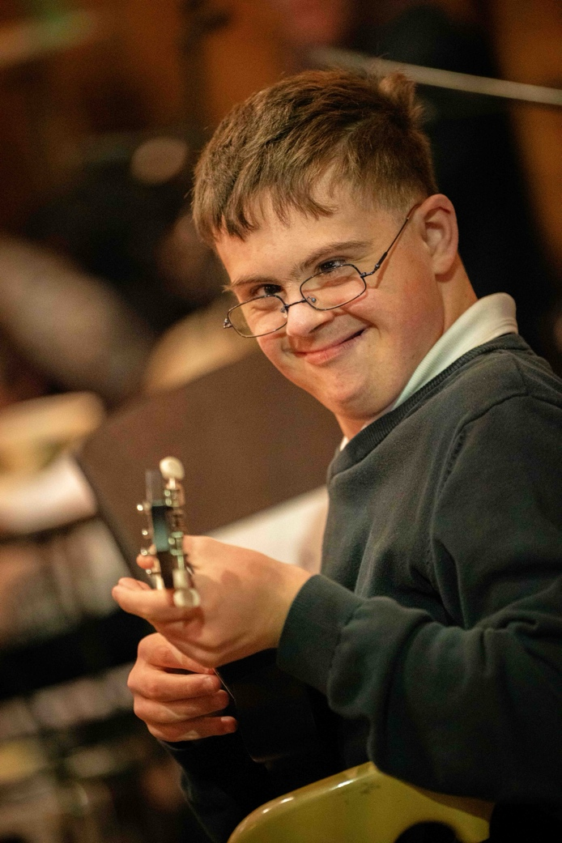
Qualifications: Educated to Degree level or equivalent

Skills and Experience
• Two years’ experience working in a project
coordination role
• Knowledge of the music education sector in Scotland and beyond
• Experience of working in the Charity/Arts sector or
Creative Industries
• Full current UK Driving Licence

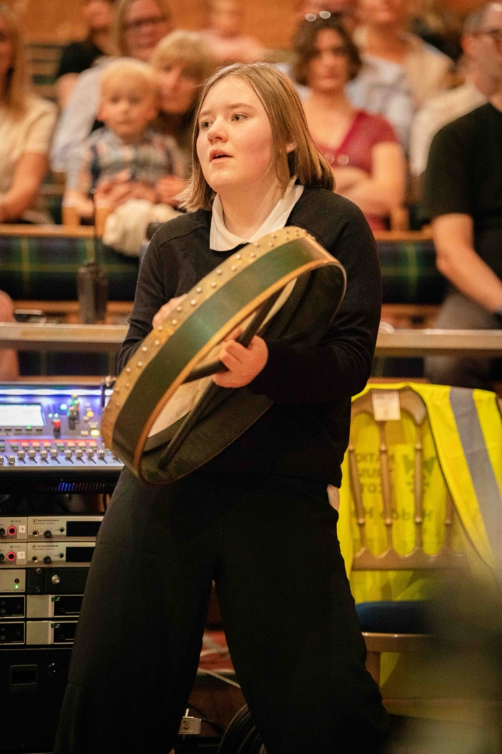

Drake Music Scotland
SPACE
11 Harewood Road
Edinburgh
EH16 4NT
info@drakemusicscotland.org
drakemusicscotland.org

Drake Music Scotland is a charity registered in Scotland No. SC026908

